**Project Design Phase-II**

**Data Flow Diagram & User Stories**

|  |  |
| --- | --- |
| Date | 30 June 2025 |
| Team ID | LTVIP2025TMID35420 |
| Project Name | Revolutionizing Liver Care : Predicting Liver Cirrhosis Using Advanced Machine Learning Techniques |
| Maximum Marks | 4 Marks |

# Data Flow Diagram

A Data Flow Diagram (DFD) is a traditional visual representation of the information flows within a system. A neat and clear DFD can depict the right amount of the system requirement graphically. It shows how data enters and leaves the system, what changes the information, and where data is stored.The following DFD Level 0 represents the information flow for the Liver Cirrhosis Prediction System.

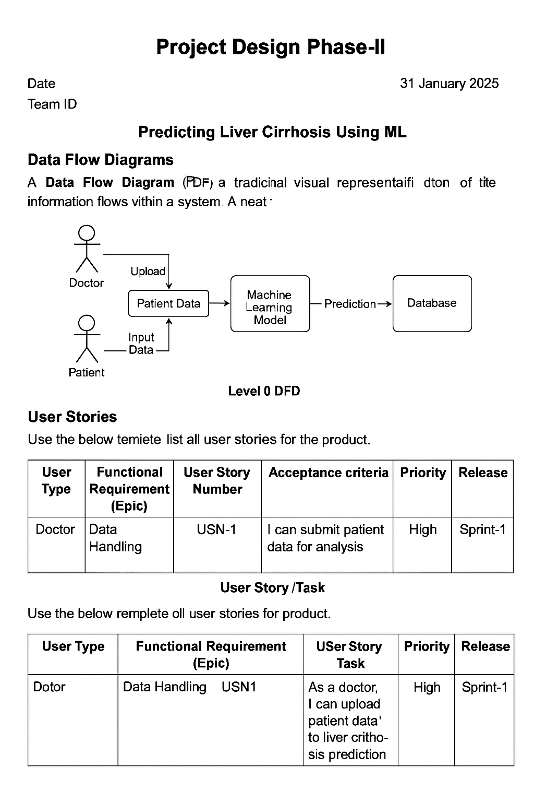

# User Stories:

|  |  |  |  |  |  |  |
| --- | --- | --- | --- | --- | --- | --- |
| **User Type** | **Functional Requirement (Epic)** | **User Story Number** | **User Story / Task** | **Acceptance Criteria** | **Priority** | **Release** |
| Doctor (Admin) | Data Upload | USN-1 | As a doctor, I can upload patient liver test data in CSV format | Patient data successfully stored in database | High | Sprint-1 |
| ML Engineer | Preprocessing | USN-2 | As an engineer, I want to preprocess missing/categorical values | Dataset is cleaned and ready for model input | High | Sprint-1 |
| ML Engineer | Model Training | USN-3 | As an engineer, I can train a model to predict cirrhosis using Random Forest | Model achieves at least 85% accuracy | High | Sprint-1 |
| User (Web) | Prediction Interface | USN-4 | As a user, I can input liver health metrics and get prediction | System returns prediction within 5 seconds | Medium | Sprint-2 |
| Admin | Model Monitoring | USN-5 | As admin, I can see daily prediction logs and performance metrics | Admin dashboard updates live metrics | Low | Sprint-2 |